20 April 2007 The Weekly Bulletin of Rotary Club of Kathmandu Mid-Town Bc # 42 of 2006-07
Rotary Club of Kathmandu Mid-Town
Breakfast Chatter




District : 3290 Web: www.rotarymidtown.org.np Club Id : 26776

APRIL IS THE MAGAZINE MONTH
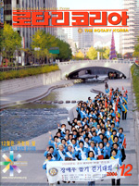
The Rotarian and the Rotary World Magazine Press enjoy a mutually cooperative and beneficial working relationship. Information is freely shared, as is expertise and help in the field. This successful system enables RI to distribute its international message throughout the world via this unique communications network. Articles and photographs from each monthly issue of The Rotarian are sent to the regionals, including the "President's Message," "Member Notes," and PolioPlus columns as well as special features promoting the RI theme and the international convention. But while helping spread the Rotary International message, at the same time each magazine is able to retain its individual identity, national flavor, and editorial freedom.

A recent Board of Directors' meeting in progress
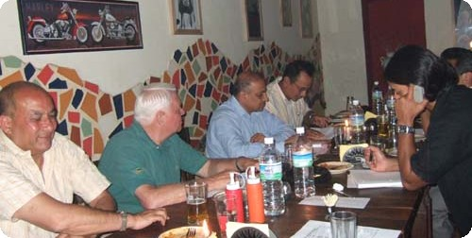
Secretary Rabi hates having his own Mobile with him ! But he loves using it anyway !!

Weekly Meetings and Programs :
Date | Program/Speaker | Program/Topics of Presentation
20 April 2007 | Club assembly | Club assembly (5)
27 April 2007 | Mangal Man Shakya | Illegal wildlife trade
4 May 2007 | Dr Dwarika Dhungel | Governance issues
11 May 2007

Friday, 20 April :
This will be the fifth Club assembly of the year when Service Avenue Directors and Project Coordinators/ Directors will be discussing activities and projects – progress reviews, budget crunches and other hurdles, new project proposals, etc at the Club meeting.

No water ? Can We Help It Out ?
Life has been much easier ever since a group of youths of Ikhache Tole, Lalitpur combined their intellect and effort to collect and store free-flowing water, that otherwise went waste – of the nearby stone spout, and turned it into a sustainable means of meeting their water requirements.
Sushil Shrestha, the key architect behind developing the technology, who is also president of the Organization of Historic Stone Spouts and Source Conservation, proudly says that people in the beginning didn't believe his plan would materialize, he is now happy that it has brought happiness and comfort to 200 households.
Three years ago the group collected Rs 500,000 from 200 houses as voluntary contribution to install a 10,000-liter tank on a four story high tower, install three electric motors to pump the water and set up connections to each house.
Each household, that pays Rs 100 every month and is supplied about 250 liters a day in dry season and 350 liters in the rainy season.
Source: The Kathmandu Post

On Lighter Side : Click at the figure ⇩


Environmental concerns are both intensely local and completely global. A garbage-filled stream has the most impact on those who rely on it for drinking water, but it also damages an entire ecosystem. A heavily polluted city hurts the health of its own inhabitants as well as those hundreds of miles downwind. As we learn and understand more about the course of climate change, we become more acutely aware that there are no local decisions. Everything we do touches others.
RI President William B. Boyd

20 April 2007 The Weekly Bulletin of Rotary Club of Kathmandu Mid-Town Bc # 42 of 2006-07

Editor: RR Shrestha, Club Service Director email: rryes@wlink.com.np

